**DAILY ONLINE ACTIVITIES SUMMARY**

|  |  |  |  |  |  |  |
| --- | --- | --- | --- | --- | --- | --- |
| **Date:** | **23-06-2020** | | | | **Name:** | **Shetty Disha Ravindra** |
| **Sem & Sec** | **VI B sec** | | | | **USN:** | **4a17cs087** |
| **Online Test Summary** | | | | | | |
| **Subject** | | PAP(assignment 4) | | | | |
| **Max. Marks** | | 16 | **Score** | | | 20 |
| **Coding Challenges** | | | | | | |
| **Problem Statement:** Write a Java Program to traverse a binary tree using PreOrder traversal without recursion. | | | | | | |
| **Status:executed** | | | | | | |
| **Uploaded the report in Github** | | | | **Yes** | | |
| **If yes Repository name** | | | | **Disha_Shetty** | | |
| **Uploaded the report in slack** | | | | **Yes** | | |
| **PYTHON ASSIGNMENT PROGRAM**  **1**] **Python Program to Count the Number of Blank Spaces in a Text File**  Screenshot (91).png | | | | | | | |

Online Test Details: (Attach the snapshot and briefly write the report for the same)

Coding Challenges Details: (Attach the snapshot and briefly write the report for the same)

Online test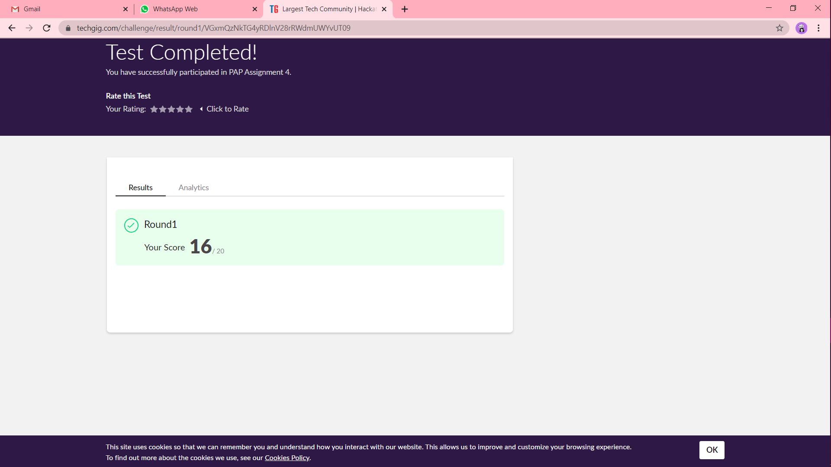

Coding challenge output

